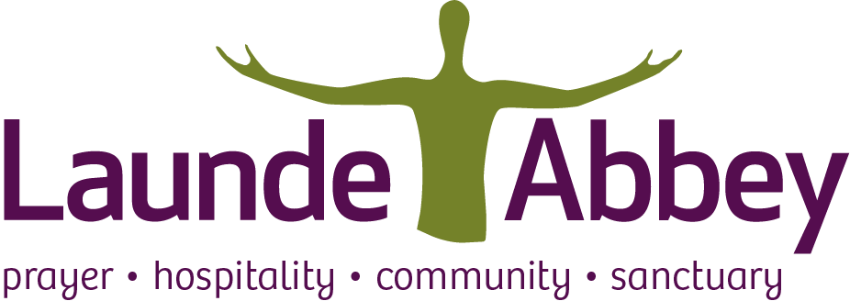

Launde Abbey Programme Retreat

Mindfulness 2025
Retreat Questionnaire
Confidential

About your experience of meditation & mindfulness

- I have no experience of meditation or mindfulness
I've had some experience
I've had a lot of experience
(please tick which applies)

- Tell me briefly what drew you to this retreat:

Information about your health needs. (This information will remain confidential to the retreat leader).

- Do you have any physical health issues that may make it difficult for you to participate fully? Yes or No

- Please indicate if you have any mobility &/or medical needs, including diabetes type 1:

- Have you had any recent disturbing life events, which may make the retreat difficult for you? Yes or No

- Have you experienced bereavement in the past year? Yes or No

- Are you dependent on alcohol or non-prescribed drugs? Yes or No

- Have you ever been diagnosed with any mental health issues? If so, it would be helpful if you could give details.

- If you are supported by a community mental health care team, please call me on the number below so that together, we can decide if a mindfulness course or retreat is right for you at this time.

- Please add any other information about your wellbeing that you think might be helpful for me to know.

Thank you for taking the time to complete this.
Please return this directly to me (along with any questions) nicola@everydaymindfulnesswithnicolasmith.com
If you need to call me, please do so: 07812 686944.

