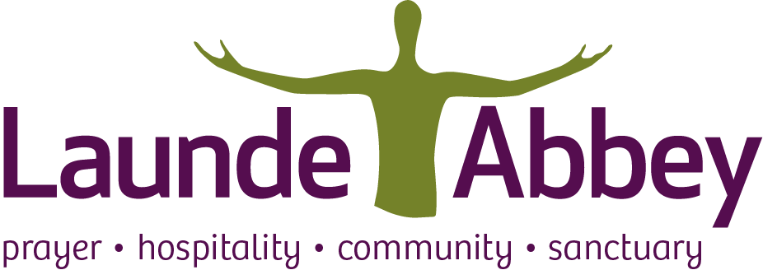

Launde Abbey Programme Retreat
Mindfulness
Pre-Retreat Information
15th – 18th July 2024

Dear friends,

I am really looking forward to our Mindfulness retreat at beautiful Launde Abbey this July.
The intention is to offer a nourishing retreat experience for your exploration of mindfulness, prayer, and stillness, but before we start let me introduce myself…
I am an experienced, BAMBA-registered Mindfulness teacher, carrying out my studies and training at the University of Bangor’s ‘Centre for Mindfulness Research and Practice,’ and with the Oxford Mindfulness Centre. I teach mindfulness to individuals, groups, students and staff, teaching staff teams and I’m passionate about sharing the benefits of mindfulness. In my local church (Northamptonshire) I am also a Lay Worship Leader and have recently been involved in setting up a Julian Contemplative Prayer Group.

Many of us find our times of prayer & stillness are filled with distractions and often focusing can be challenging. During this retreat, we explore the foundations of mindfulness, as taught in secular mindfulness courses, however, we will discover together how these can support our spiritual life, attentiveness, and stillness.
We will be focusing on Scripture and its wisdom about prayer and stillness - exploring the connections with mindfulness practices. A precious opportunity and space to discover or rediscover “that a deep and God-given stillness and peace was available to us even in the midst of the brokenness and chaos of our lives.” (Mark Williams, Emeritus Professor of Clinical Psychology, Honorary Canon of Christ Church Cathedral, Oxford).
To help you gain the most from this retreat, it would be helpful to understand your pre-existing experience of mindfulness – and also, to be aware of any health issues you may wish to share (in confidence of course). This will ensure that I can cater for your needs appropriately and with sensitivity.
Mindfulness Practices
We will be trying out several different mindfulness practices and, although meditation and mindfulness can be helpful in managing stress, depression and anxiety, some practices might not be suitable if you are experiencing recent bereavement, depression or other significant mental health issues. Please be aware that it may not be possible to offer the level of individual support you need if things are very difficult for you.

Your Health and Wellbeing
To help support you in the best possible way, and for you to get the most out of this retreat – I have designed a brief questionnaire. Please don’t feel overwhelmed – it is simply a tool to help confirm that this retreat is the ‘right fit’ for you at this point in time. Please do answer the questions below carefully. If you are not sure how to answer, or if you would prefer to discuss these issues over the phone (adding detail or clarification) – you are welcome to contact me directly.
Should you have any concerns regarding your attendance – please do call me first to discuss (see contact details below). If after mutual discussion, it materialises that it is not the right time for you to come on this retreat – we can speak directly with Launde Abbey, regarding the possibility of refunding or transferring to a course at a later date.

Confidentiality and GDPR
Please be assured that the information you give will only be seen by me, will not be shared, and will be used solely for the purpose of this retreat. All questionnaires will be destroyed by me at the retreat end.
To ensure full confidentiality, please could you return your information direct to me at the email address shown at the end of this letter. Please do not return your forms to Launde Abbey.

And finally – some suggested items to bring with you: warm, comfortable clothing layers, a light blanket/wrap & cushion to help you sit in comfort and a phone, i-pad/tablet or laptop to give the possibility of accessing additional meditations, if you wish.
I look forward to hearing from you, and indeed meeting you in person in a few weeks’ time.

Warmest wishes,

Nicola
Tel: 07812 686944 Email: nicola@everydaymindfulnesswithnicolasmith.com

NB: You may wish to note that there will be further courtesy emails sent out from Launde Abbey approximately one week before the retreat.

